**Escherichia Coli growth with and without boundaries on CellModeller**

**Avimanyu Bandyopadhyay 15-9-18**

Experiment 1. Without Boundaries:

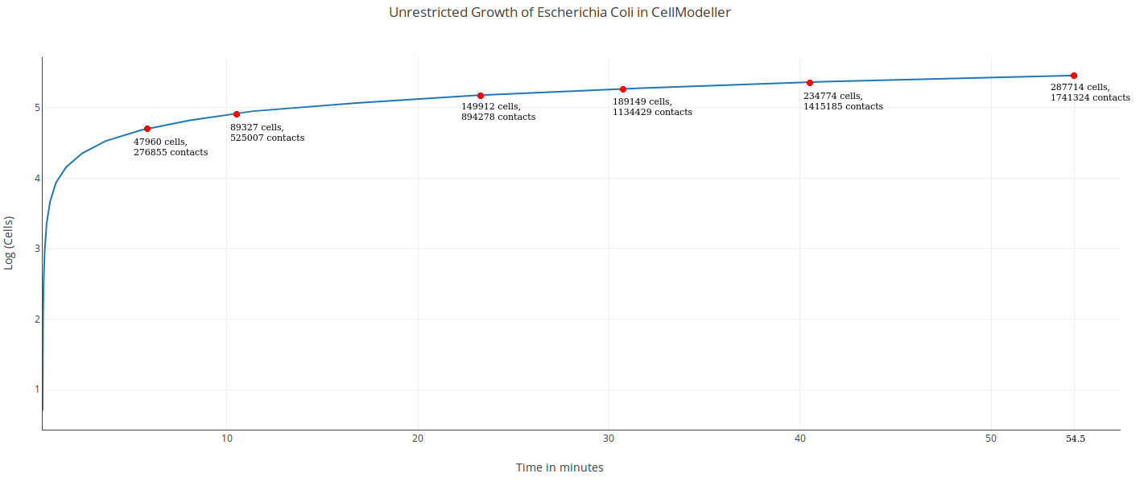

287714 cells with 1741324 contacts were produced in 54.5 minutes.

Experiment 2. With Boundaries:

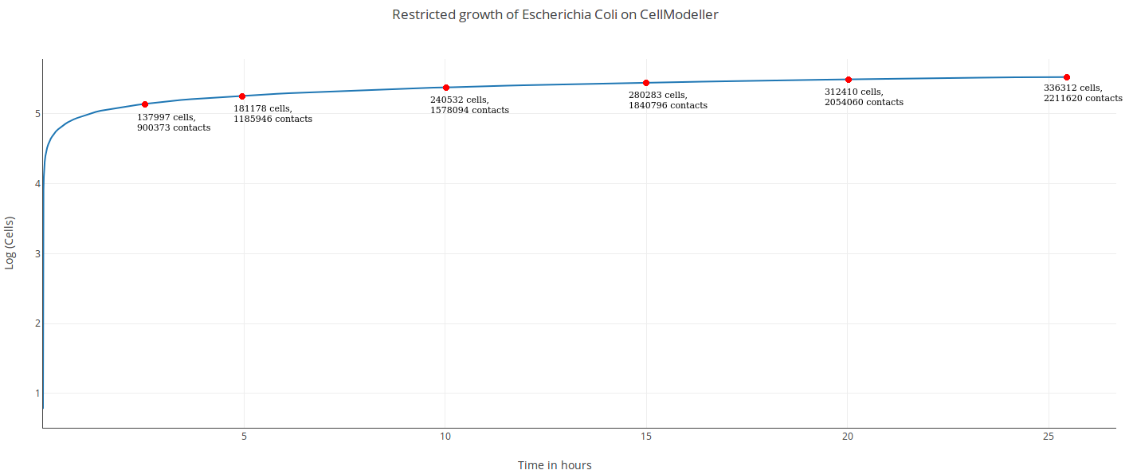

Comparatively, 288327 cells with 1894242 contacts were produced in 16.37 hours. The simulation ended with 336312 cells, 2211620 contacts in 25.45 hours.

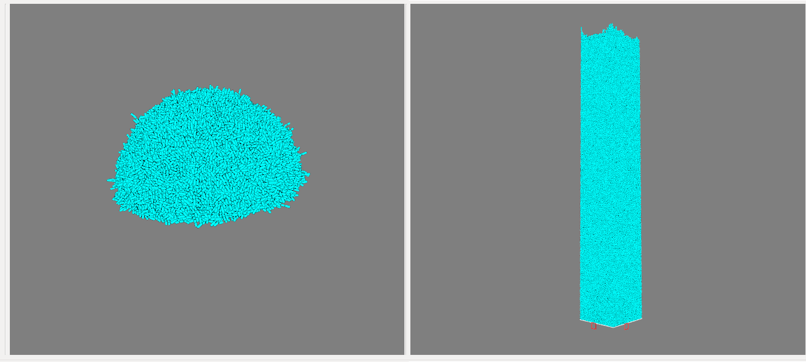

Figure: Side by side comparisons of experiment 1 vs experiment 2 on CellModeller

Questions that need to be answered(left this part as on S.Aureus results):

1. Looking at the above two cases, which of them is representative of biofilm growth and which one is growth of a multicellular organism?
2. How is growth time related to the establishment of the 2 growth models?

Comparison with earlier experiment in 2016:

330991 cells with 2177129 contacts were produced in 24.66 hours with boundaries on Siddhant's GTX 980 Ti GPU that has the same architecture (Maxwell) as that of current Titan X GPU. So computationally both are on similar benchmarks. On repeating the same on Titan X, we noted 332264 cells with 2185381 contacts in 24.2 hours comparatively, before it ended with 336312 cells, 2211620 contacts in 25.45 hours. So, it was slightly faster than 980 Ti (produced more than 1000 cells in lesser time).